**Experiment No: 16**

**Name of the Experiment:** Study Of Newton Central Difference Method To Predict Unknown Value(s) For Any Geographic Point Data.

**Objectives:** The objective of this experiment is to use Newton Central Difference method to find out the very precise values of the given data point, using MATLAB.

**Theory:**

**Tool:** MATLAB Software

**Methodology:**

**MATLAB Code:**

x=[1921 1931 1941 1951 1961 1971];

fx=[35 42 58 84 120 165];

n=size(x,2);

%array of zeros

dt=zeros(n,n);

%% inserting x and fx in dt

for i=1:n

dt(i,1)=x(i);

dt(i,2)=fx(i);

end

dt

z=3;

for k=1:n-1

i=1;

for j=1:n-k

dt(j,z)=(dt(i+1,z-1)-dt(i,z-1));

i=i+1;

if(j>n)

break;

end

end

z=z+1;k=k+1;

end

dt

%value for fx to find

x_int=1947;

%determining u=(x-x1)*h

u=(x_int-x(n/2))/(x(2)-x(1));

%% determining sum by formula

y_sum=dt(n/2,2)+u*(dt(n/2,3)+dt(n/2-1,3))/2+(u*u)/2*(dt(n/2-1,4));

a=0;b=0;l=1;t=1;

for i=3:n-1

k=1;

if((n/2-(i-2))<=0 || (n/2-(i-1))<=0)%cross limit dt(0,i)

break;

else

a=(dt(n/2-(i-2),i+2)+dt(n/2-(i-1),i+2))/2;

b=dt(n/2-(i-1),i+3);

if(i<=n/2)

l=u*(u*u-t*t);

t=t+1;

end

for j=1:i

k=k*j;

end

y_sum=y_sum+(l/k)*a+u*l*b;

end

end

y_sum

%% ploting the graph

plot(x, fx, 'bo', x_int, y_sum, 'r*')

axis([1900 2000 0 250])

xlabel('x')

ylabel('y')

**Output:**

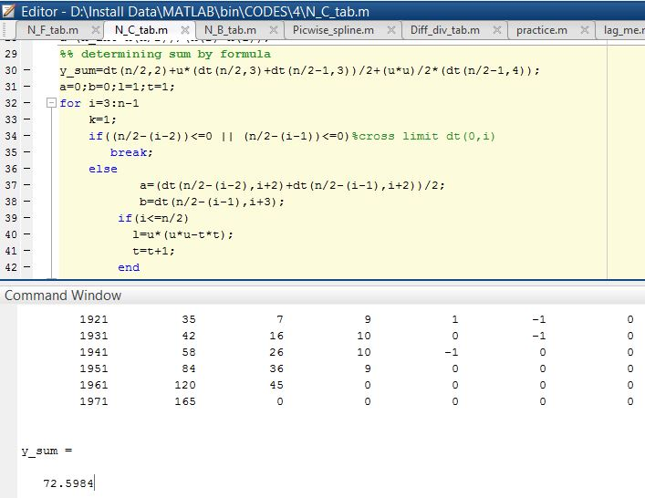

**-----------------------------------------------------------------------**

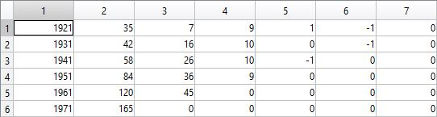

**Figure 13.1: Table of Newton Central Difference**

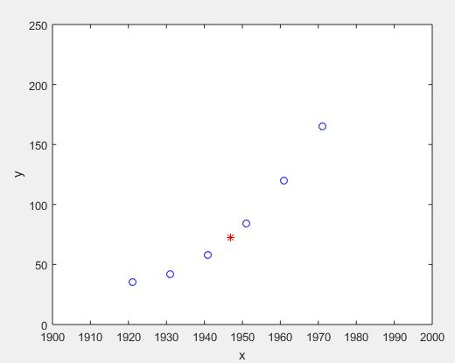

**Figure 13.2: Graph Of The Function**

**Result(s)& Discussion:** The unknown values for x = 1947 is y = 72.5984 .

**Conclusion:** We have found the approximate unknown value for 1947 which is same as text book[1].

**References:**

[1]C. Chapra and P. Canale Raymond , “*Numerical Methods for Engineers”,* 7th ed. McGraw-Hill Education, 2 Penn Plaza, New York, NY 10121, 2015